Computer Architecture
Homework 7
Theme: External Memory
All questions carry equal weight. Show your work.

- (DISK) Define track, cylinder and sector. Draw the disk format of a typical Winchester disk.

On a magnetic disk, data is organized on a platter in a concentric set of rings, referred as tracks. Each track is the same width as the head. There are thousands of tracks per surface. Adjacent tracks are separated by gaps.

Data are transferred to and from the disk in sectors. There are typically hundreds of sectors per track, and these may be of either fixed or variable length. In most contemporary systems, fixed-length sectors are used, with 512 bytes being the nearly universal sector size.

Some disk drives accommodate multiple platters stacked vertically a fraction of an inch apart. Multiple arms are provided. Multiple–platter disks employ a movable head, with one read-write head per platter surface. All of the heads are mechanically fixed so that all are at the same distance from the center of the disk and move together. Thus, at any time, all of the heads are positioned over tracks that are of equal distance from the center of the disk. The set of all the tracks in the same relative position on the platter is referred to as a cylinder.

Winchester disk format:
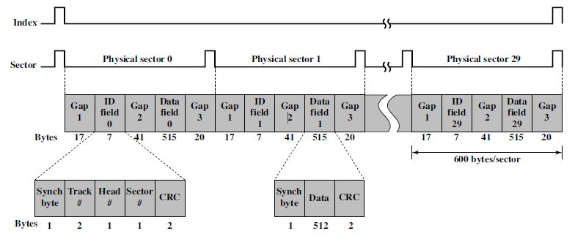

- (DISK/CD) Define rotational delay, access time and transfer time. Does the hard drive/CDROM run on CLV or CAV? Why is the capacity of DVD more than a CD?

When the disk drive is operating, the disk is rotating at constant speed. To read or write, the head must be positioned at the desired track and at the beginning of the desired sector on that track. The time it takes to position the head at the track is known as seek time.

Once the track is selected, the disk controller waits until the appropriate sector rotates to line up with the head. The time it takes for the beginning of the sector to reach the head is known as rotational delay.

The sum of the seek time and the rotational delay equals the access time, which is the time it takes to get into position to read or write.

Once the head is in position, the read or write operation is then performed, i.e. data is transferred, as the sector moves under the head. The time required for the transfer is referred as the transfer time.

Data is stored on a magnetic disk / hard drive in concentric tracks. Data on tracks is accessed at the same rate by rotating the disk at a fixed speed, known as constant angular velocity (CAV). With CAV system, number of bits per track is constant.

CD-ROM disk contains a single spiral track, beginning near the center and spiraling out to the outer edge of the disk. Sectors near the outside of the disk are the same length as those near the inside. Thus, information is packed evenly across the disk in segments of the same size and these are scanned at the same rate by rotating the disk at a variable speed. Data is then accessed at a constant linear velocity (CLV).

DVD’s greater capacity is due to three differences from CDs:
- Bits are packed more closely on a DVD using a laser with shorter wavelength.
- DVD employs a second layer of pits and lands on top of the first layer. A dual layer DVD has a semi-reflective layer on top of the reflective layer, and by adjusting focus, the lasers in DVD drives can read each layer separately. This technique almost doubles the capacity of the disk.
- DVD-ROM can be two sided, whereas data are recorded on only one side of a CD.

- Very briefly define the seven RAID levels, providing information about stripe size, synchronization, data transfer rate and their applications. (total less than a page)

RAID 0:
- Data are striped across the available disks.
- Advantage of this layout is that if a single I/O request consists of multiple logically contiguous strips, then individual strips for that request can be handled in parallel, greatly reducing the I/O transfer time.
- If the typical request is for large amounts of logically contiguous data, compared to the size of a strip, then a single I/O request involves the parallel transfer of data from multiple disks, increasing the effective transfer rate compared to a single-disk transfer.
- If the strip size is relatively large, so that a single I/O request only involves a single disk access, then multiple waiting I/O requests can be handled in parallel, reducing the queuing time for each request.
- Applications in which performance and capacity are primary concerns and low cost is more important than improved reliability.
- Applications: Video production and editing; Image Editing
RAID 1:
- In RAID 1, redundancy is achieved by duplicating all the data.
- Data striping is used. Each logical strip is mapped to two separate physical disks so that every disk in the array has a mirror disk that contains the same data.
- Advantages: A read request can be serviced by either of the two disks that contains the requested data. A write request requires that both corresponding strips be updated, but this can be done in parallel. However, there is no write penalty. Recovery from a failure is simple. When a drive fails, the data may still be accessed from the second drive.
- Disadvantages: The principal disadvantage of RAID 1 is the cost; it requires twice the disk space of the logical disk that it supports.
- Applications: System software and data and other highly critical files.
- Applications: Accounting; Payroll; Financial
- In a transaction-oriented environment, RAID 1 can achieve high I/O request rates if the bulk of the requests are reads. RAID 1 may also provide improved performance over RAID 0 for data transfer intensive applications with a high percentage of reads. Improvement occurs if the application can split each read request so that both disk members participate.
RAID 2:
- RAID levels 2 and 3 make use of a parallel access technique. In a parallel access array, all member disks participate in the execution of every I/O request. Typically, the spindles of the individual drives are synchronized so that each disk head is in the same position on each disk at any given time.
- An error-correcting code such as Hamming Code is stored along with data bits.
- Data striping is used. In the case of RAID 2 and 3, the strips are very small, often as small as a single byte or word.
- Disadvantage: Although RAID 2 requires fewer disks than RAID 1, it is still rather costly. The number of redundant disks is proportional to the log of the number of data disks.
- On a single read, all disks are simultaneously accessed. On a single write, all data disks and parity disks must be accessed for the write operation.
- Applications: Environment in which many disk errors occur. No commercial implementations exist / not commercially viable.
RAID 3:
- Similar to RAID 2, RAID 3 employs parallel access, with data distributed in small strips.
- Instead of an error-correcting code, a simple parity bit is computed for the set of individual bits in the same position on all of the data disks.
- RAID 3 requires only a single redundant disk, no matter how large the disk array.
- In the event of a drive failure, the parity drive is accessed and data is reconstructed from the remaining devices. Once the failed drive is replaced, the missing data can be restored on the new drive and operation resumed.
- Because data are striped in very small strips, RAID 3 can achieve very high data transfer rates. Any I/O request will involve the parallel transfer of data from all of the data disks.
- Disadvantage: Only one I/O request can be executed at a time. Thus, in a transaction-oriented environment, performance suffers.
- Applications: Video production and live streaming; Image editing; Video editing; Prepress applications

RAID 4, 5 6 (common attributes):
- RAID levels 4 through 6 make use of an independent access technique. In an independent access array, each member disk operates independently, so that separate I/O requests can be satisfied in parallel.
- Because of this, independent access arrays are more suitable for applications that require high I/O request rates and are relatively less suited for applications that require high data transfer rates.
- Data striping is used. Strips are relatively large.
RAID 4:
- With RAID 4, a bit-by-bit parity strip is calculated across corresponding strips on each data disk, and the parity bits are stored in the corresponding strip on the parity disk.
- Disadvantage: RAID 4 involves a write penalty when an I/O write request of small size is performed. Every write operation must involve the parity disk, which therefore can become a bottleneck.
- Applications: No commercial implementations exist / not commercially viable
RAID 5:
- RAID 5 distributes the parity strips across all disks.
- Advantage: The distribution of parity strips across all drives avoids the potential I/O bottleneck found in RAID 4.
- Applications: File and application servers; Database servers; Web, e-mail, and news servers
RAID 6:
- RAID 6 distributes the parity strips across all disks.
- Two different parity calculations are carried out and stored in separate blocks on different disks. Thus, a RAID 6 array whose user data require N disks consists of N+2 disks. This makes it possible to regenerate data even if two disks containing user data fail.
- Advantage: RAID 6 provides extremely high data availability.
- Disadvantage: RAID 6 incurs a substantial write penalty, because each write affects two parity blocks.
- Applications: mission critical applications

- Discuss the effectiveness of data striping in RAID 0 for the following two cases:

- A single process requests large data sets

If the application requests large amounts of logically contiguous data, compared to the size of a strip, then a single I/O request involves the parallel transfer of data from multiple disks, which increases the effective transfer rate compared to a single-disk transfer.

- Multiple processes request several small sized data

If the strip size is relatively large, so that a single I/O request only involves a single disk access, then multiple waiting I/O requests can be handled in parallel, reducing the queuing time for each request. This improves I/O response time and facilitates high I/O execution rates.

- What is flash memory? What are the differences among NOR and NAND flashes?

Flash memory is a type of semiconductor memory which is typically used in consumer electronic products. In recent years, cost and performance of flash memory have improved and it is now feasible to use flash memory drives as secondary storage.

There are two types of flash memory – NAND flash and NOR flash. Listed below are differences between the two types of flash memory.

Attribute | NOR Flash | NAND Flash
Logical organization | resembles a NOR logic device | resembles NAND logic devices
Basic unit of access | bit | 16 or 32 bits
Access type | High speed random access  Read and write to specific locations  Can reference / retrieve a single byte | Does not provide a random access  Reads / Writes in small blocks; each block holds 100s/1000s of bits  Provides higher bit density than NAR flash and greater write speed
Applications | Used to store cell phone operating system code and on Windows computers for BIOS program that runs at startup | Used in USB flash drives, memory cards and in SSDs

- IEEE Computer magazine, August 2013 issue discusses Next Generation Memories. Write a 1-page report about next generation memories.
The memory technologies currently available in market are primarily of two types:
- Solid-state memory based on electron storage in transistors, for e.g. SRAM, DRAM and flash
- Mechanical memory based on magnetic storage, for e.g. tape, hard disk
These memory technologies have long life, reasonable cost and density and have been scalable over the past tens of years. Over a period of time, the needs of memory capacity in devices has increased drastically. This requirement for rapid density growth and cost reduction of memory is addressed by scaling underlying technologies to ever-smaller feature sizes and thus smaller memory-bit sizes, to the extent of using only a few tens of electrons to store memory state in a 20-nm NAND MLC memory unit for e.g.
Recent advances in modern manufacturing tools towards capability of manipulating materials at the atomic level and in the ability to model fundamental storage physics are paving way for further innovation in memory technologies, which are even more scalable than current devices. Discussed below is a brief overview of some of the new memory technologies.
Conventional memory technologies, for e.g. DRAM and NAND flash, exploit the capacitance from electrical charge stored in the memory cell. They have the restriction on storage density scaling with reduced cell area. To overcome this limitation, new resistance-based memory technologies, for e.g. phase-change RAM (PRAM), magnetic RAM (MRAM), or resistive RAM (ReRAM), are being developed. In comparison with conventional capacitance-based memory technologies, these nonvolatile memory technologies are faster and can more easily accommodate scaling to sub-20-nm nodes. The rest of this report concentrates on resistance-based memory technologies.
Phase-Change RAM (PRAM):
PRAM is recommended for standard interface or storage memory applications because of its non-volatility, relatively fast operational speed, and scalability.
PRAM basically applies two phases of chalcogenide materials: the amorphous phase with high resistance and the crystal phase with low resistance. Controlling the write voltage and time can reversibly transform the written data from amorphous phase to the crystalline phase. The read data is the result of sensing the resistance difference between the two phases.
Using advanced cell technologies, full integration scheme is developed for 20-nm technology node. Retention tests for 20-nm cell array showed the feasibility of maintaining stored data for 10 years at 85°C. But, thermal disturbance will be a critical factor in developing a PRAM cell. The joule heating in narrow adjacent cells will require a cell structure with a special thermal-blocking scheme or doped phase-change materials that are extremely thermally stable.
Magnetic RAM (MRAM):
MRAM uses tunneling resistance that depends on the relative magnetization directions of ferromagnetic electrodes.6-8 It is an attractive memory option because of its superior scalability, speed, and power consumption. Depending on the writing technique, MRAM is classified as either field switching or spin-transfer torque (STT MRAM, the latter type being of more interest because of its simple structure and excellent scalability.
Two factors decide how far MRAM can shrink: the critical current density, which is the current density for magnetic switching and the thermal stability factor, which is closely correlated with retention. Critical current density should be as low as possible to fully exploit MRAM’s low power consumption and high density advantages. In contrast, the thermal stability factor should be as high as possible to guarantee reliable device functionality. Adjusting process parameters requires a tradeoff between the two.
Several challenges remain for sub-20-nm MTJ cells and need further development effort on optimizing the ferromagnetic electrode’s composition, upgrading the MTJ stack scheme, and developing advanced MTJ patterning technology.
Resistive RAM (ReRAM):
ReRAM operation is mainly field-induced ion migration and hence has a relatively slow speed and limited endurance, relatively good data retention and a simple cell structure that is easy to manufacture. The potentially low cost to fabricate ReRAM makes it attractive for large scale integration. 3D ReRAM architecture is developed which provides higher bit density than planar structures.
Though ReRAM has reliability advantages, low operation voltage, and random access, its power consumption is higher because it has fewer parallel working cells. In addition, for ReRAM to be a major memory product, researchers must find a way to better control its stochastic nature and variability. ReRAM’s production cost and reliability are critical factors towards its adoption in the memory market.
Summary:
In summary, MRAM can work as nonvolatile working memory if it solves scalability issues from patterning and thermal stability. PRAM’s non-volatility, random access, and relatively fast speed make it suitable as code memory and buffer memory. Even though ReRAM is just taking off, it will be a powerful data storage memory technology if researchers can develop a 3D stack structure.
Each of these memory technologies has its own market segment: MRAM has the fastest speed, which places it as a nonvolatile alternative to DRAM. PRAM and ReRAM are faster than flash memory, which places them as contenders for the flash market.
Shown in figure below, a comparison of various types of memory technologies available in market and being developed for future use. 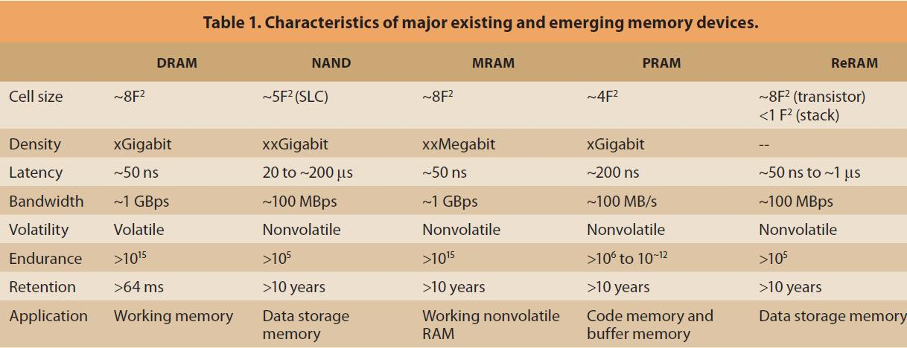
Impacts:
- New memory technologies will have tradeoffs for performance, power and cost.
- They will have transformational effect on memory usage and integration in computer systems.
- Introducing a new memory type is complex for several reasons such as
  - Storage physics need to be well understood
  - Designing large-density storage devices and state-of-the-art lithography techniques is challenging
  - Manufacturability at high volumes and yields is unproven.
References:
- "Next-Generation Memory" by Greg Atwood, Micron Technology, Soo-Ik Chae, Seoul National University, Simon S.Y. Shim, San Jose State University
- “NAND Flash Memory: Challenges and Opportunities,” by Yan Li and Khandker N. Quader at SanDisk
- “What lies ahead for resistence based memory technologies” by Yoon jong song at Samsung electronics
- “The nonvolatile memory transformation of client storage” by intel's amber huffman and dale juenemann
- “How persistent memory will change software systems” by Anirudh badam of microsoft research
- “Refactor, Reduce, Recycle: Restructuring the I/O Stack for the Future of Storage,” Steven Swanson and Adrian M. Caulfield of the University of California, San Diego

